LIBRARY RECOMMENDATION FORM
TO: Librarian/Library Acquisition Committee
FROM: ____________________________________________________________________
Position: _______________________________ Department: _________________________
Email: _____________________________________ Phone: _________________________
I recommend that our library should subscribe to the following journal:  ANNALS OF MATHEMATICS  Editors: Helmut Hofer (Institute for Advanced Study), Nicholas M. Katz, Sergiu Klainerman, Fernando Codá Marques , Assaf Naor, Zoltán Szabó (Princeton University)  The Annals is published six times a year (Jan., March, May, July, Sept., Nov.)  ISSN: 0003-486X (print) and 1939-0980 (online)  Please visit http://annals.math.princeton.edu for more information. | 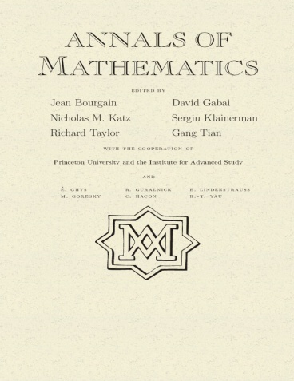
___________________________________________________________________________
Important uses for the Annals of Mathematics would include:
___ REFERENCE: I regularly refer to the Annals for new research articles related to my work.
___ STUDENT READING: I refer my students to the Annals to assist their studies
___ BENEFIT FOR LIBRARY: My evaluation of the Annals’ content and direction is very high, and it is cited and/or indexed heavily. Its acquisition will fulfill department, faculty, and student needs.
___ PERSONAL AFFILIATION: I am/intend to be an author, referee, and/or member of the Editorial Board for the Annals. I use it frequently in my work and regularly recommend articles to colleagues and students.
___ PUBLICATION OUTLET: My current research requires a publication outlet in this area. I need this journal to keep up-to-date with its editorial direction and interests.
___ OTHER: ___________________________________________________________________________
_______________________________________________________________________________________
Signature _______________________________________________________ Date ___________________

TO ORDER: Please visit out website at http://annals.math.princeton.edu/subscriptions
Annals of Mathematics, Fine Hall-Washington Road, Princeton, NJ, 08544, USA;
ph: 1-609-258-6468 fax: 1-609-258-1367

